***Module-3 = Testing on Live Application***

1. **What is RDBMS?**

* **RDBMS- Relational Database Management System**, RDBMS is the basis for SQL, and for all modern database systems like MS SQL Server, IBM DB2, Oracle, MySQL, and Microsoft Access.

1. **What is SQL?**

* **SQL- Structured Query Language**, which is a computer language for storing, manipulating and retrieving data stored in relational database.

1. **Write SQL Commands?**
2. **DDL** – Data Definition Language.
3. **DML** – Data Manipulation Language.
4. **DCL** – Data Control Language.
5. **DQL** – Data Query Language.
6. **What is join?**

* **JOIN-** is used to same data base retrieving & interlink the records from multiple tables**.**

1. **Write type of joins?**
2. **INNER JOIN**: returns rows when there is a match in both tables.
3. **LEFT JOIN**: returns all rows from the left table, even if there are no matches in the right table.
4. **RIGHT JOIN**: returns all rows from the right table, even if there are no matches in the left table.
5. **FULL JOIN**: returns rows when there is a match in one of the tables.
6. **How Many constraints and describes itself?**
7. **NOT NULL:** This constraint tells that we cannot store a null value in a column. That is, if a column is specified as NOT NULL then we will not be able to store null in this particular column any more.
8. **UNIQUE:** This constraint when specified with a column, tells that all the values in the column must be unique. That is, the values in any row of a column must not be repeated.
9. **PRIMARY KEY:** A primary key is a field which can uniquely identify each row in a table. And this constraint is used to specify a field in a table as primary key.
10. **FOREIGN KEY:** A Foreign key is a field which can uniquely identify each row in a table. And this constraint is used to specify a field as foreign key.
11. **CHECK:** This constraint helps to validate the values of a column to meet a particular condition. That is, it helps to ensure that the value stored in a column meets a specific condition.
12. **DEFAULT:** This constraint specifies a default value for the column when no value is specified by the user.
13. **What is API Testing?**

* **API- Application Programming Interface**, is a computing interface which enables communication and data exchange between two separate software systems.

1. **Types of API Testing?**

* **Open APIs**: These types of APIs are publicly available to use like OAuth APIs from Google. It has also not given any restriction to use them. So, they are also known as Public APIs.
* **Partner APIs**: Specific rights or licenses to access this type of API because they are not available to the public.
* **Internal APIs**: Internal or private. These APIs are developed by companies to use in their internal systems. It helps you to enhance the productivity of your teams.

1. **Difference between RDBMS vs DBMS?**

|  |  |
| --- | --- |
| **DBMS** | **RDBMS** |
| DBMS stores data as file. | RDBMS stores data in tabular form |
| Data elements need to access individually | Multiple data elements can be accessed at the same time |
| No relationship between data | Data is stored in the form of tables which are related to each other |
| It is used for small organization and deal with small data | It is used to handle large amount of data |
| Security is less | More security measures provided. |
| Data fetching is slower for the large amount of data | Data fetching is fast because of relational approach |

1. **What is Responsive Testing?**

* **Responsive Testing-** is a process that enables you to check how well a website or application screen size, resolutions work on various types of devices like laptops, desktops and smartphones.

1. **Which types of tools are available for Responsive Testing?**

**Tools For Responsive testing-**

1. LT Browser
2. Lembda Testing
3. Google Resizer
4. I am responsive
5. Pixel tuner
6. **What is the full form of. ipa, .apk?**

* An **IPA (iOS App Store Package)** file is an iOS application archive file that stores an iOS app. Each IPA file includes a binary and can only be installed on an iOS device.
* **APK file stands for (Android Application Package**), APK is a file extension of an Android device. APK files can normally be used in Android and a number of other Android-based Operating Systems.

1. **How to create step for to open the developer option mode ON?**

1 2 3

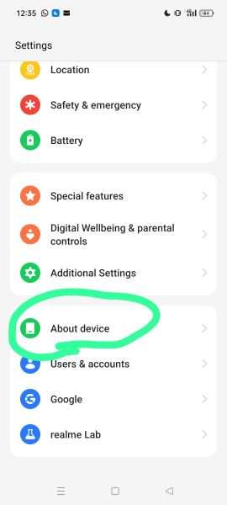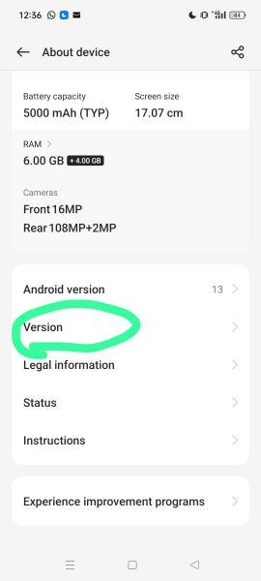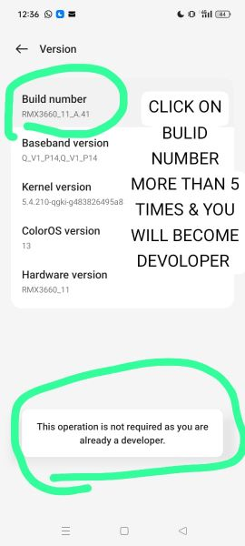

4 5 6

